Exercise 1:
The intended users are:
- Managers
- Employees
Managers:
The goal of this booking application for managers is to allow them “to manage office-space bookings for themselves or on behalf of others”. This means that managers should be able to book any office space they may need (e.g., for meetings) and to also approve and cancel employees request to use a certain office space during a certain period. The managers are responsible to avoid double bookings to make sure that multiple employees don’t book an office-space for the same time, to prevent potential conflicts and keep productivity to a maximum. Mangers will have extra permissions to employees as they approve and cancel room bookings and they should be able to view booked or vacant rooms.
Managers have many principal tasks that they should complete like viewing room availability, manage employee request and book rooms for a specific date and time. The environmental and user considerations that must be considered is the responsive design, ease of use (clear ways to select specific date/times and clear buttons to manage employee request) and clear way to authorise between managers and employees. Considering these will allow me to create a more effective application to allow managers to effectively use it no matter the device they use.
Employees:
The goal of this booking application for employees is to allow them to view available booking rooms and allow them to book, cancel and view their bookings. Employees should be responsible to book their own rooms and cancel if there is a change of plans. Employees should have permission to view all available rooms and book them. This will allow them to stay productive as they can manually request a room booking instead of asking their manager which will help improve productivity.
Employees also have many principal tasks such as viewing, booking and cancelling rooms and be able to access the application. Environmental and user considerations I must consider are time pressure as they may need to quickly book rooms, responsive design as employees might access multiple devices to book based on their location and also internet connectivity as employees need internet access to be able to use the application.

Exercise 2:
Login:
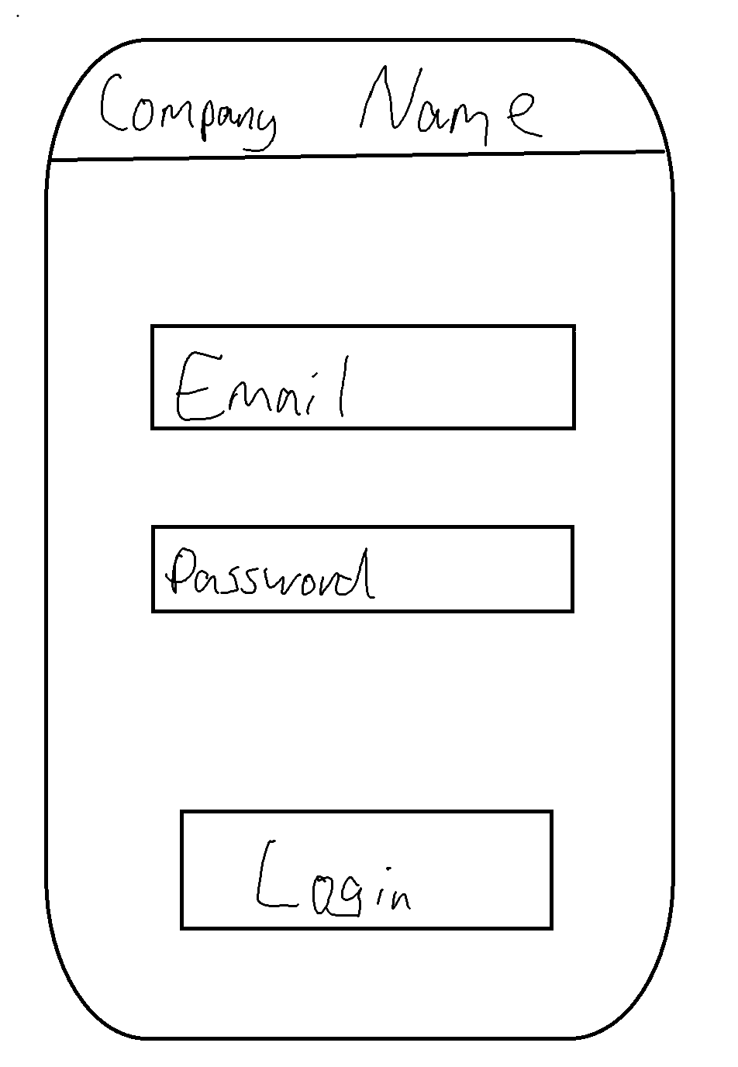
List of current rooms booked:
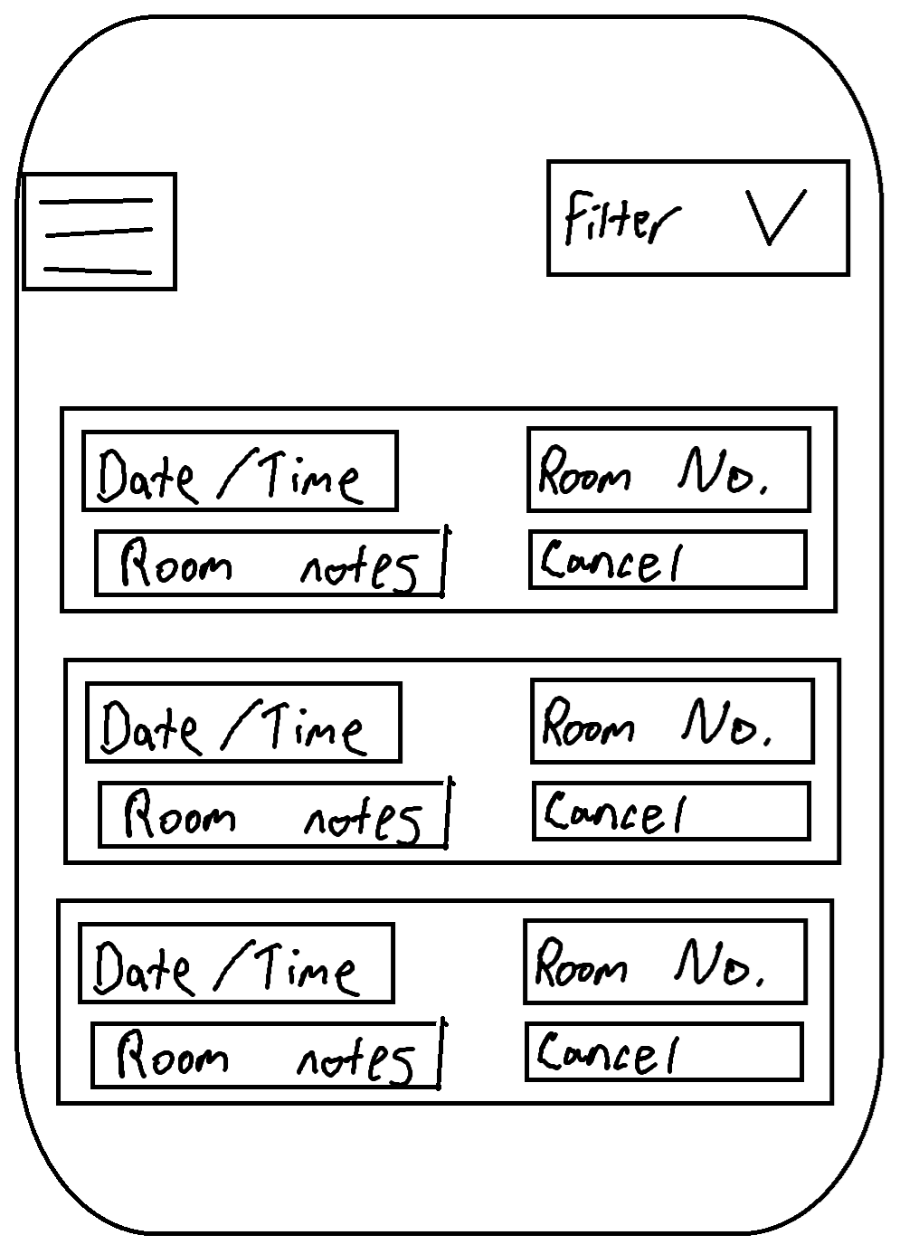

Navigation:
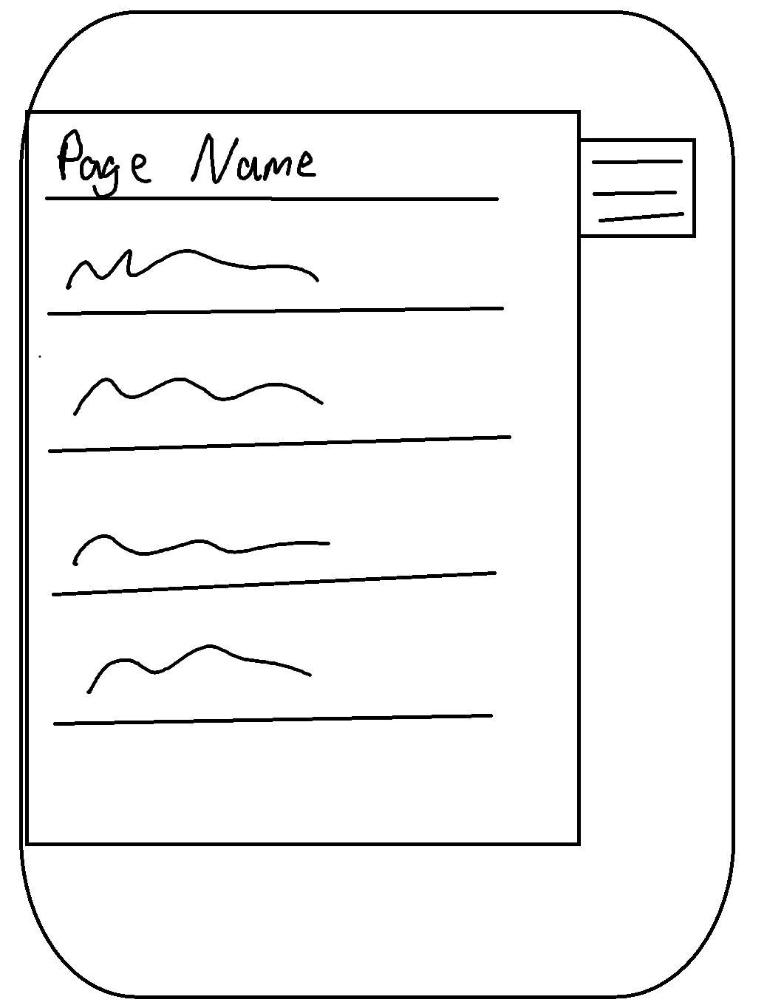
Manage employees booked rooms – Managers only:
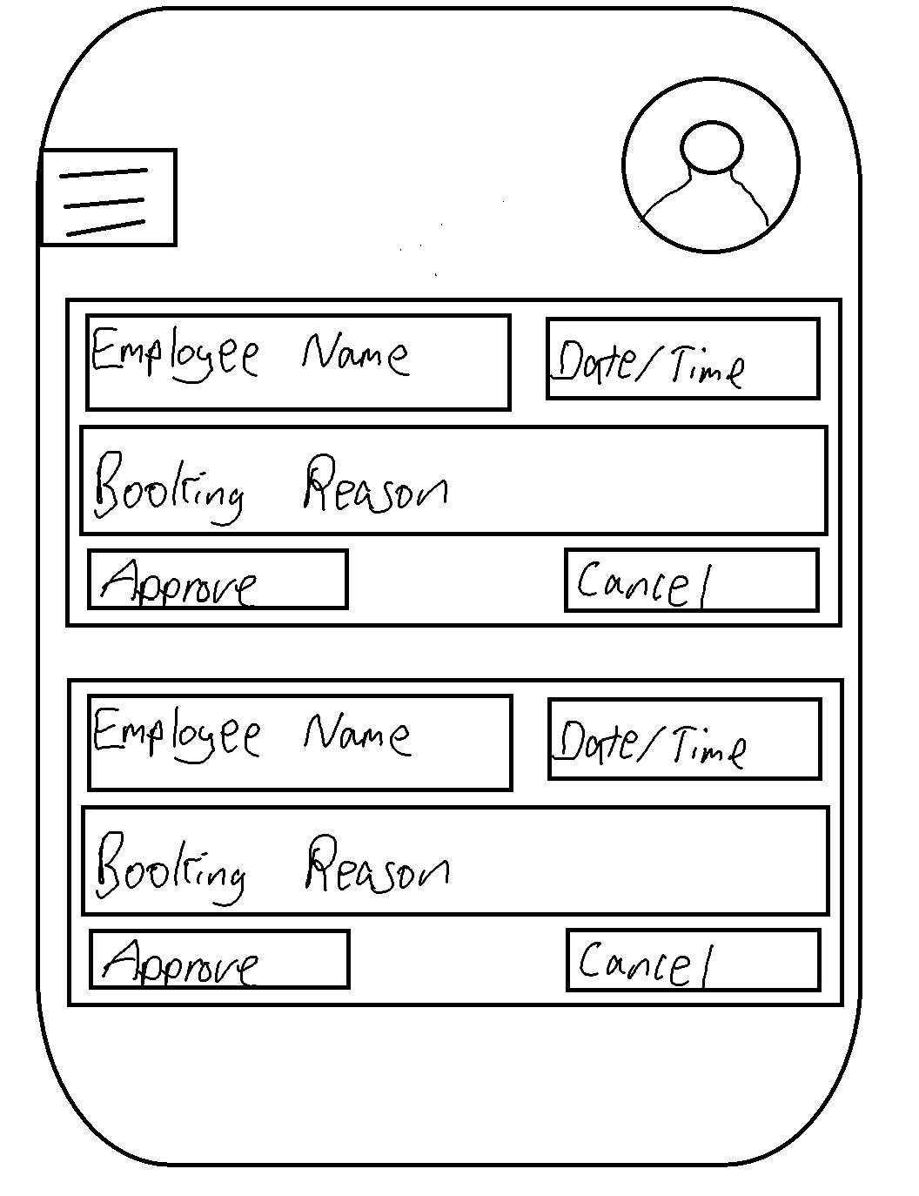
Room booking:
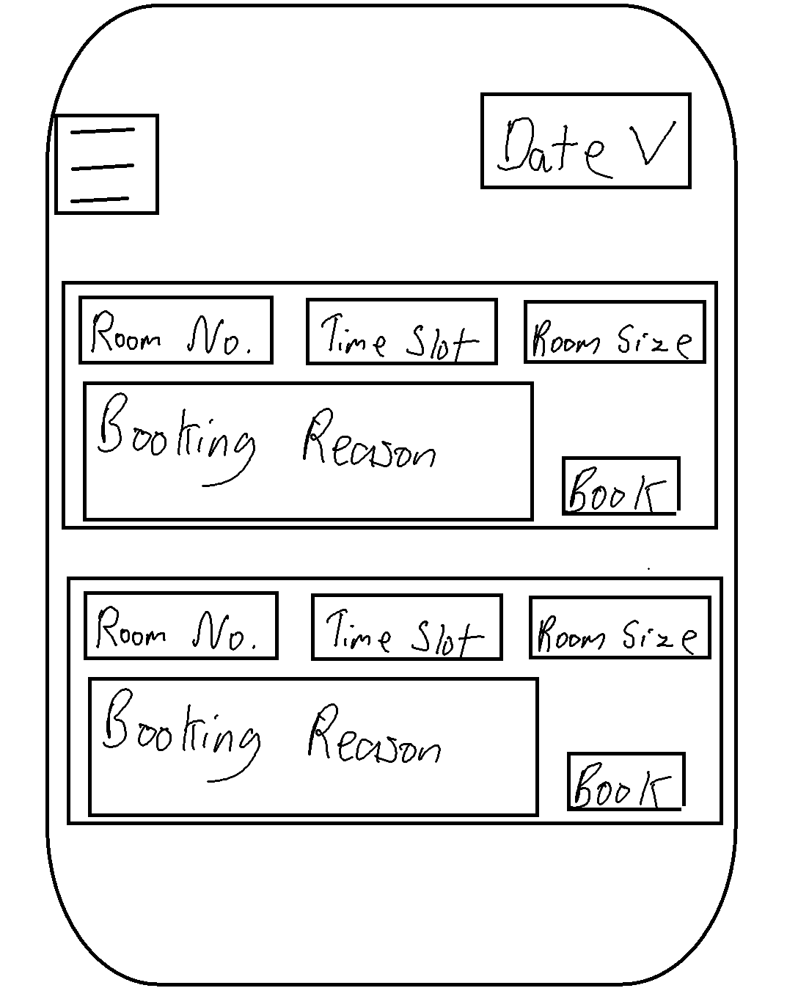
Booked or vacant rooms – Managers only:
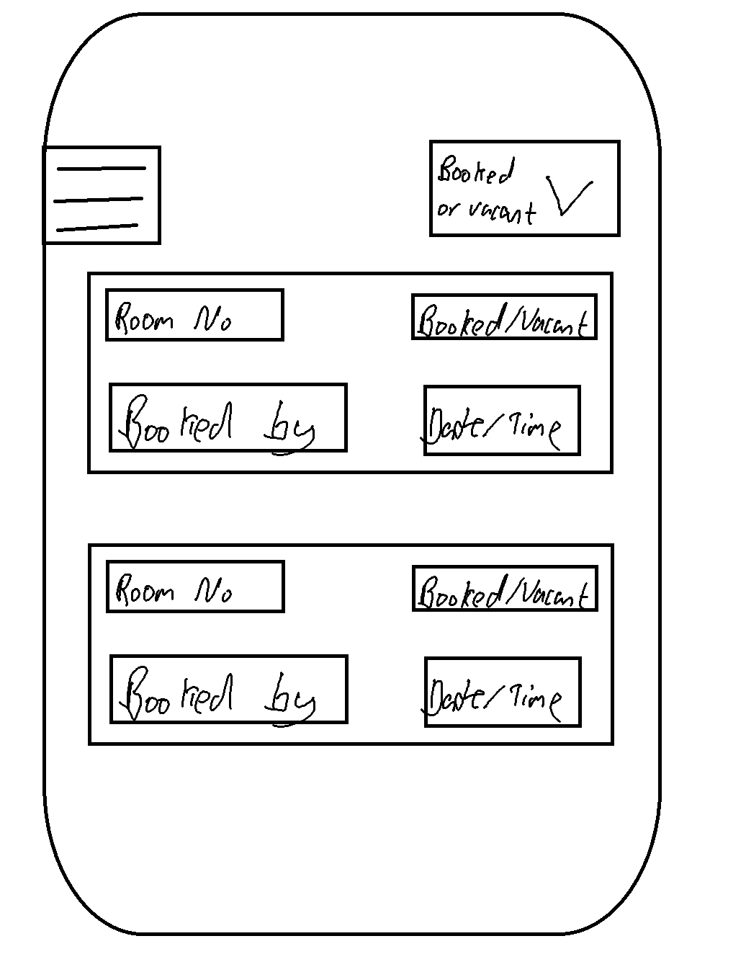
Navigation Task flow:
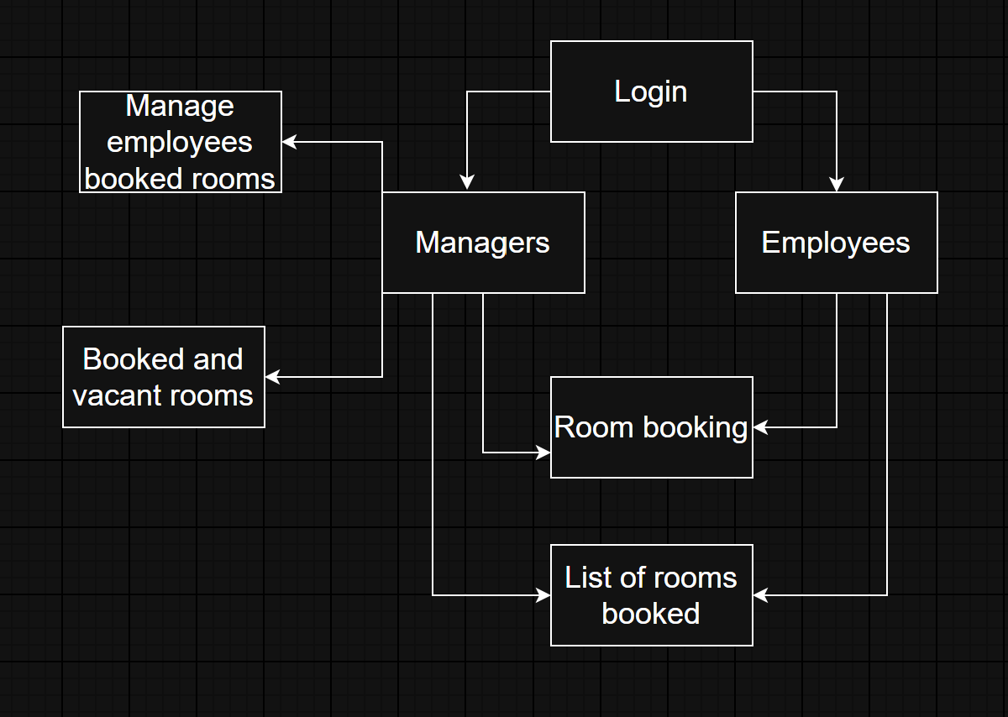
How booking work for employees:
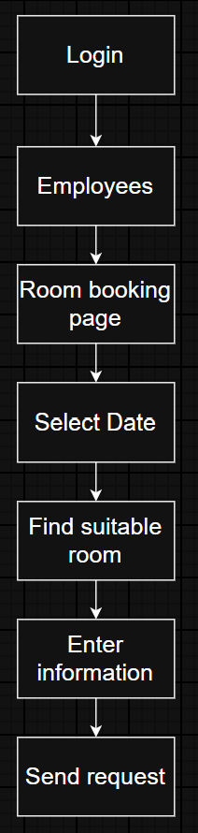
Employees will start by logging into their account by entering their email and password. They will then use the navigation to get onto the room booking page. They will then use the calendar to select the date they need to book a room for. After that they will find an available time slot they suit them and then fill in all the relevant information. Finally, they will book the room which will send a notification to their manager where they can view it and approve or cancel based on what they see fit.

How managers can view vacant or booked rooms:
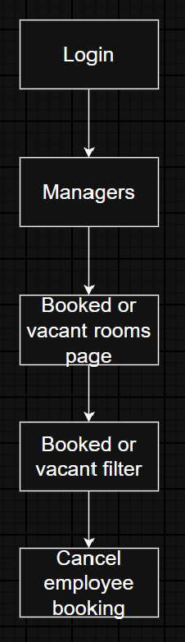
Managers start by logging into their account like employees and will then navigate to this page. They can then use the filter to view vacant rooms or pre-booked rooms. They will have permission to then cancel any employee bookings if they no longer need it or if the room is needed for a more important meeting.
HCI principles considered:
A HCI principle I have considered is consistency. I have done this by using a consistent navigation, where users can access it in the same way and each has the same layout no matter the page. Also, I will use the same colour scheme, text size and font based on each page based on the importance of the information. Another HCI principle that I have considered it error prevention. When making the app I will make sure that employees are not able to book rooms that have already been booked as once a room has been booked it will be removed, so that employees can no longer view it. Therefore, preventing the chance of multiple employees booking the same room. Finally, another HCI principle I have considered is ease of use. I will make sure that the app is easy to use for all users to have improve user experience and increase efficacy as they can use the app quicker and easier. Therefore, helping improve productivity for the business.

Exercise 3:
I have carried out an evaluation on my LFP so that I can gain vital feedback on strengths, weakness of my designs to help me improve them when redesigning. I asked 2 people to provide me feedback on my LFP. The first participant was someone from the course. The reason I asked this participant is so I can receive more technical feedback from someone who has more computing knowledge. Then for my second participant I asked a friend who doesn’t take computer science as they don’t know much about computers which allowed me to gain feedback from a more likely user who would use it for work.
Feedback Questions:
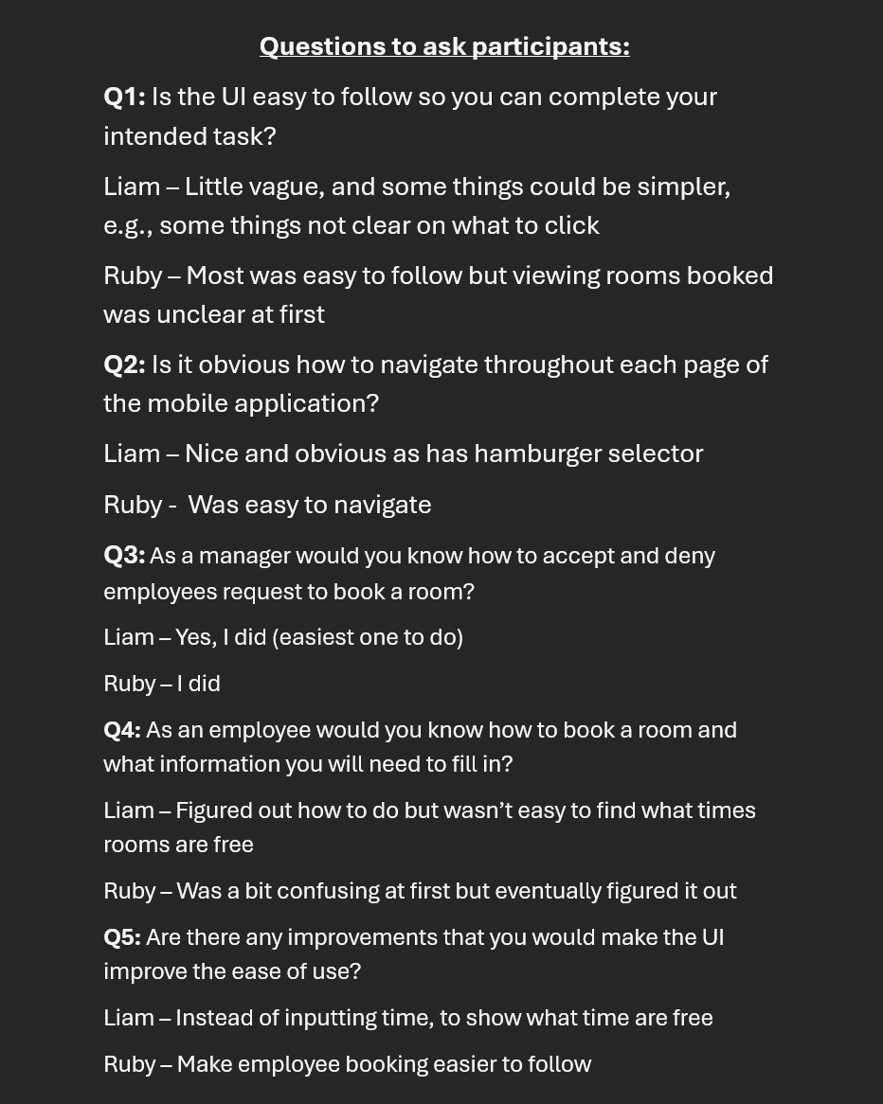
Consent Form:
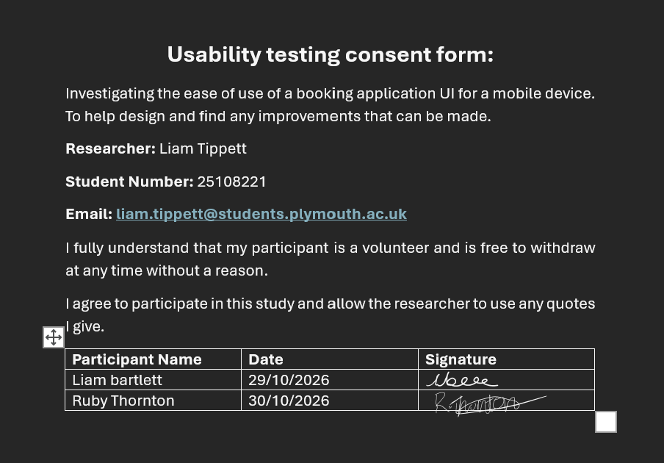

Exercise 4:
Based on my feedback, both participants found the navigation easy to follow. Therefore, I don’t need to make any changes to the navigation flow.
Navigation:
Navigation Task flow:

Login Page:
Feedback received about logging page was “standard login page so was easy to use”. Therefore, this page also doesn’t need changes.
Viewing booked or vacant rooms – managers only:
I added the user image which will allow them to logout and I showed the difference between booked room and vacant rooms when filter is used. I also added max room capacity on the vacant room slots.
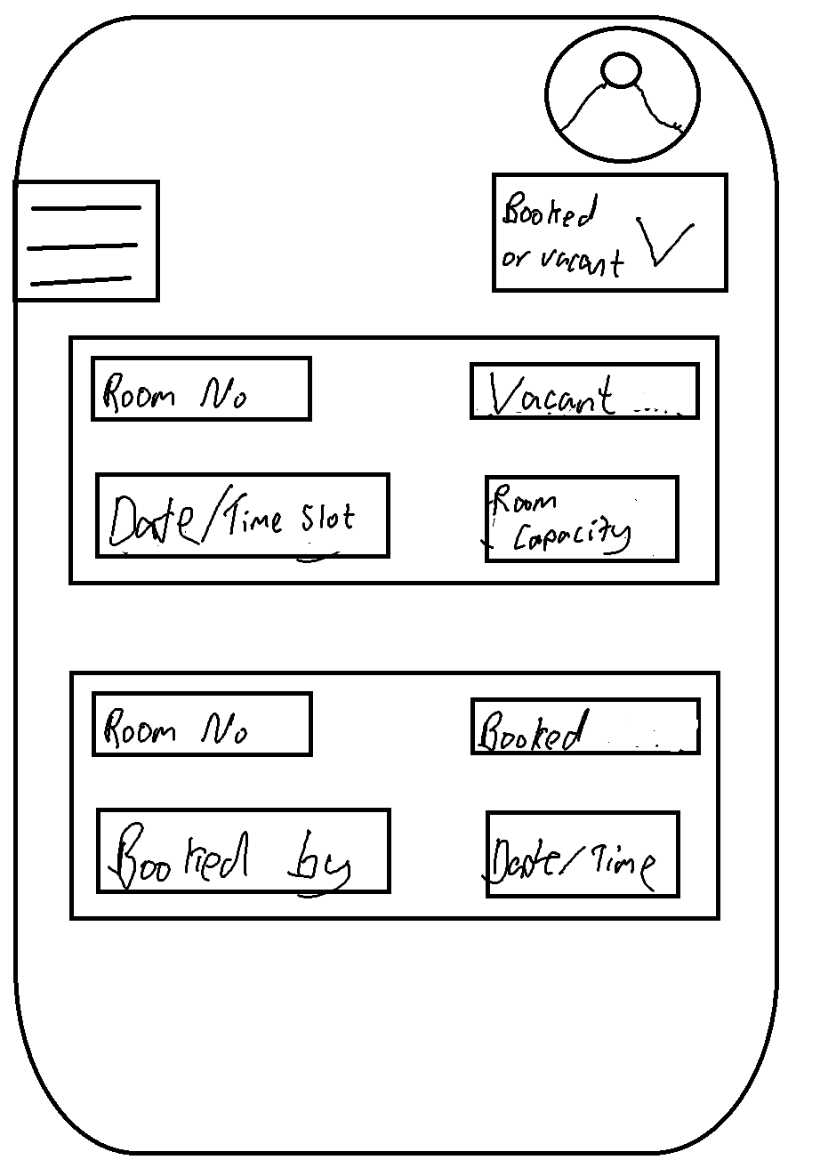

View user booked rooms:
Based on my feedback, it was clear on the purpose of this page. But once I explained its purpose the participants knew how to use it. Therefore, in my redesign I have tried to make it clear what intended purpose of this page.
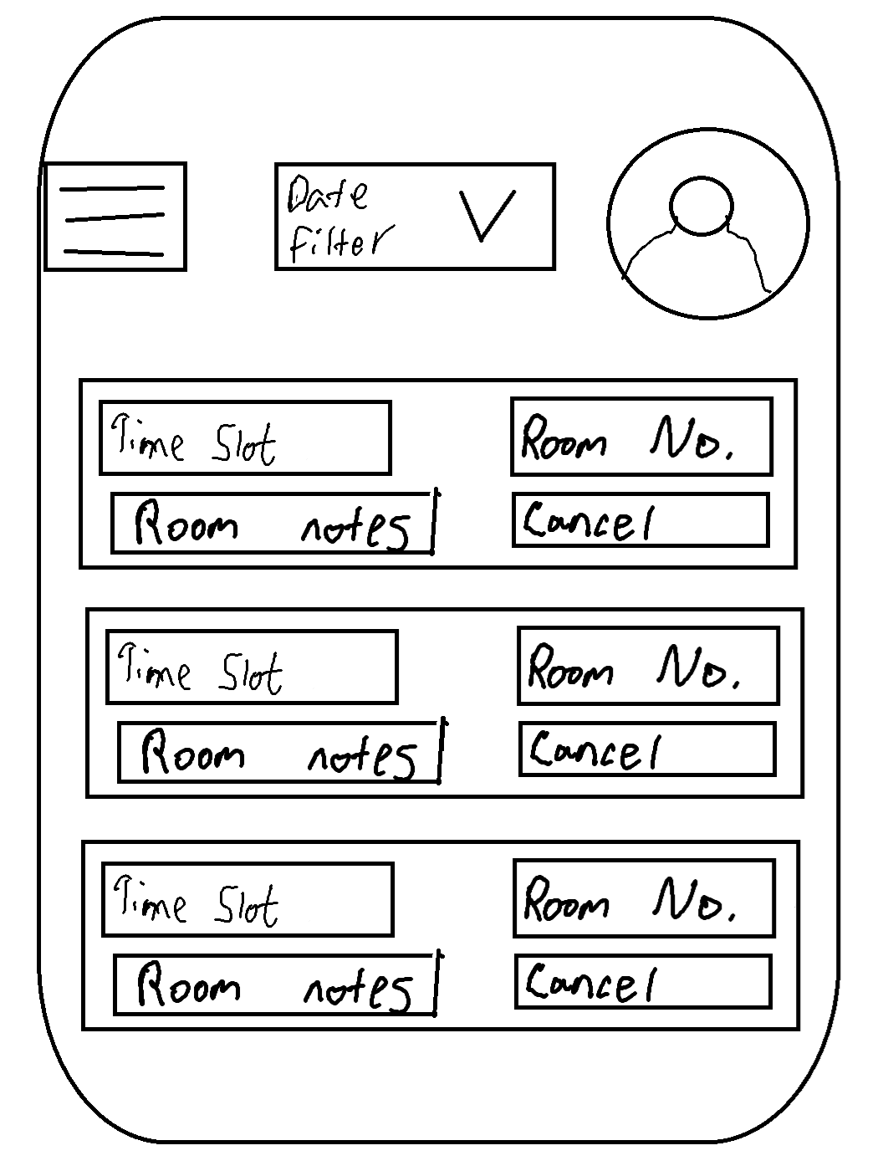
Manage employees booked rooms – Managers only:
Based on feedback, I have added the employee image next to their name to make it more clear to managers which employee has booked the room as the manager could be new and still learning all the employee’s names. Additionally, I have also added a date filter so that the manager can filter through the bookings based on dates.
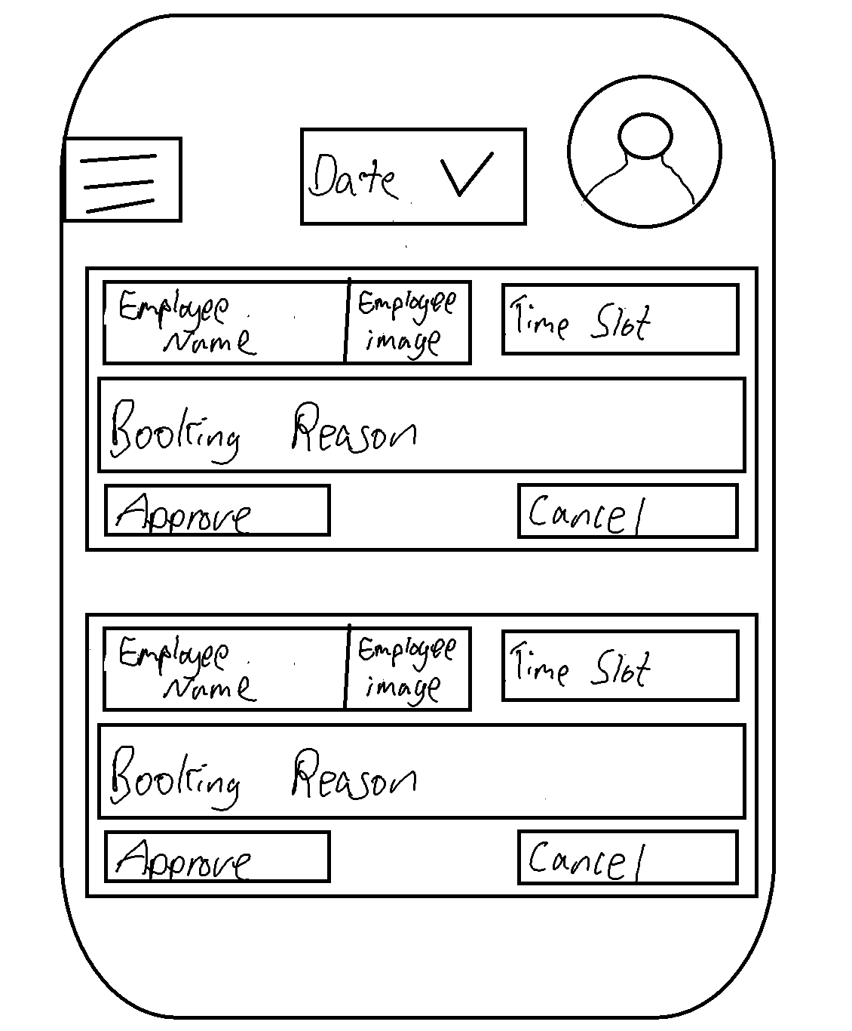
Booking a room:
Based on feedback provided by Liam he mentioned how it is unclear whether a room is available or unavailable. Therefore, I have added an indicator which will show users if the room is available to book or if it has already been booked. Additionally, I have also added the employee image to allow them to easily logout of their accounts.
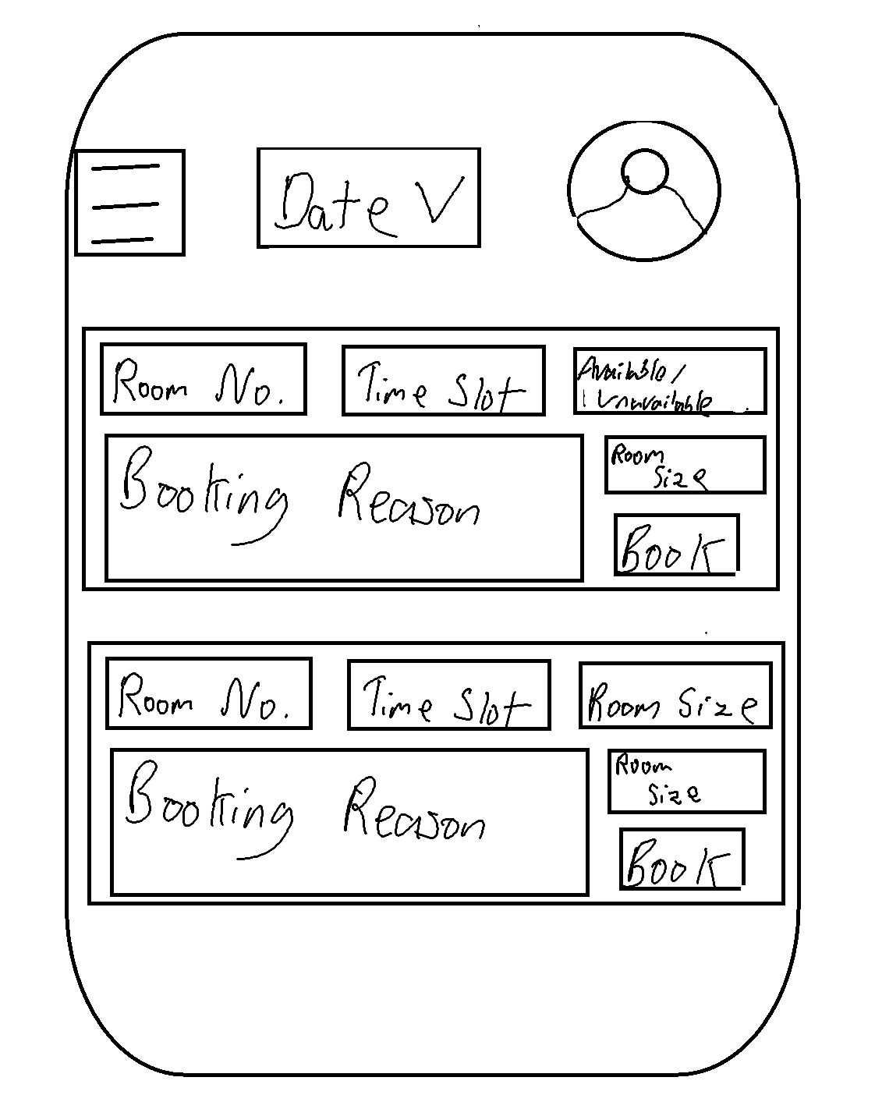
Feedback also showed that the task flow for employees and managers was easy to follow, so no need to change those also.

Set Exercise 5:
I will be creating the high-fidelity user interface for employees. I will also make sure the app is responsive for mobile devices and landscape for tablets.
I have also created a drawable called bg_input so that I can use it across multiple components and if I want to change the design, I only have to do it once instead for each component.
Login page:
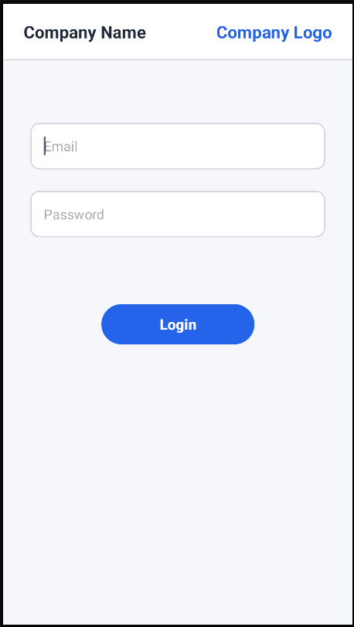
Navigation:

Booking a room:

Viewing user booked rooms:

